Pip install requests

  
https://www.youtube.com/watch?v=qx2LGtKzjxk

Pip install wget

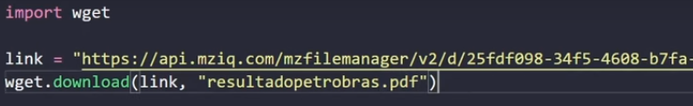  
https://www.youtube.com/watch?v=bGoRlMM2DxQ